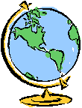
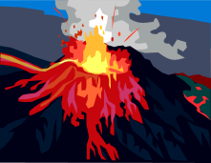
Tectonic Processes
Key
Vocabulary
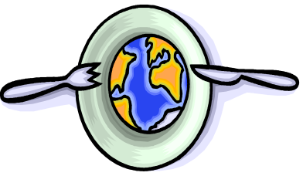
tectonic plates | Sections of the earth that move about and cause earthquakes and volcanoes.
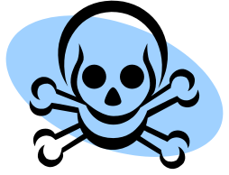

natural hazard | A great force of nature, such as an earthquake or volcano, which is a threat or a danger to people.
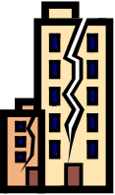

earthquake | A movement or tremor in the Earth that can cause damage to buildings.
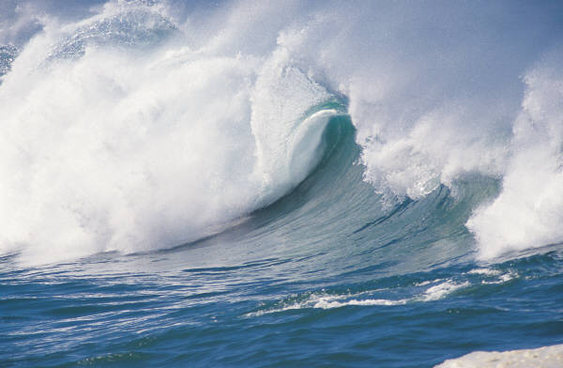
tsunami | Huge, destructive, waves caused by earthquakes that occur under the ocean.
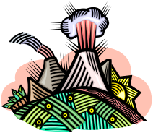

volcano | A cone-shaped mountain or hill often made up from lava and/or ash.
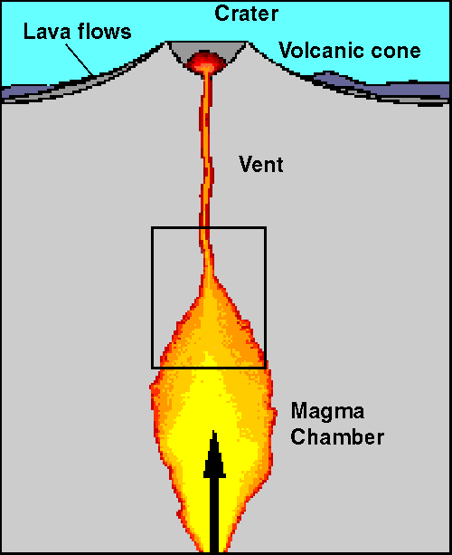

magma | Molten (melted) rock stored below the Earth’s surface.
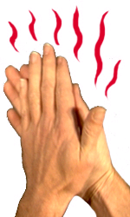

friction | The resistance when one thing moves against another. This leads to the build up of pressure.

focus | The place beneath the ground where an earthquake starts.

epicentre | The point on the ground directly above the focus of an earthquake.

lava | Molten rock flowing out of the ground.

  active | Describes a volcano which has erupted recently and is likely to again.

dormant | Describes a volcano which has erupted in historical times (i.e. the last 2000 years) but not recently.
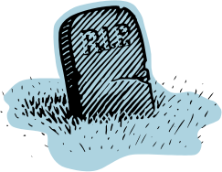
extinct | Describes a volcano that has not erupted in historical times and is not expected to erupt again.

Richter scale | The scale used to measure the size of an earthquake.
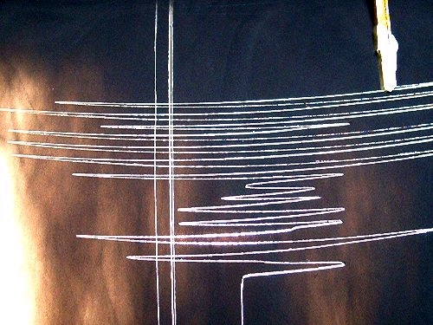
seismograph | An instrument used to measure earthquakes.

seismic wave | Describes a wave of energy that moves through the Earth’s crust during an earthquake.

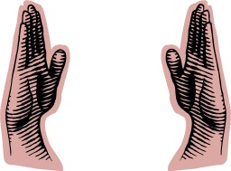
magnitude | The term used to describe the size (i.e. how powerful or destructive) of an earthquake.

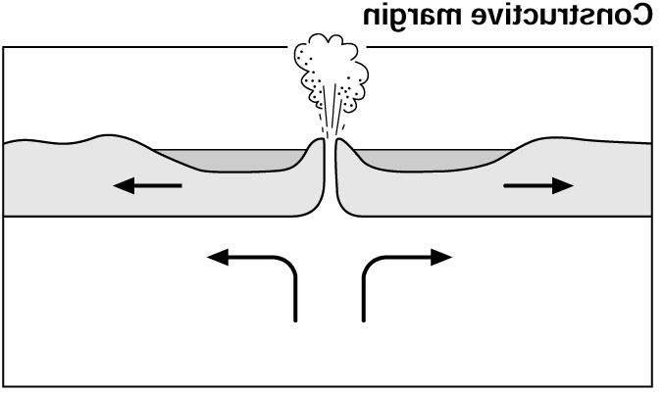
constructive | A type of plate margin where the Earth’s crust is CREATED. Examples of a constructive plate margin can be found in Iceland.

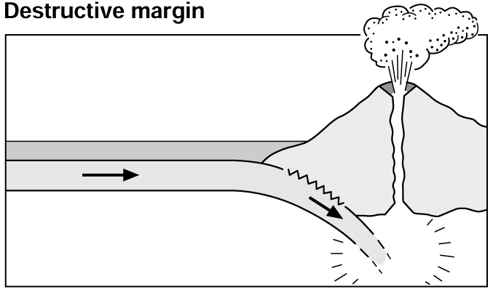
destructive | A type of plate margin where the Earth’s crust is DESTROYED. Examples of a destructive plate margin can be found on the west coast of south America.
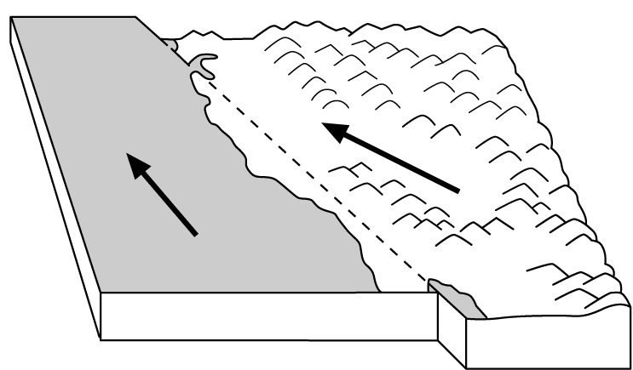
conservative | A type of plate margin where the Earth’s crust is NEITHER destroyed or created. An example of a conservative plate margin can be found in California, USA.

